|  |
| --- |
| **MINI PROJECT REPORT**  **ON**  **BroCodes: C++ Tutorial Website**  as a part of  ***Project Based Learning***  **Submitted by**  **Dixit Vedant Haresh**  **Hingrajiya Shyam Niteshbhai**  **Shinde Aniket Rajendra**  **Guided by**  **Prof. Mariyam Maniyar**  Master of Computer Applications  (Under Faculty of Engineering)  Department of MCA  K. K. Wagh Institute of Engineering Education & Research  Hirabai Haridas Vidyanagari, Amrutdham, Panchavati,  Nashik – 422 003 |

|  |
| --- |
| **K. K. Wagh Institute of engineering education & research**  **NasHik - 422003**  ***CERTIFICATE***  This is to certify that  **Dixit Vedant Haresh**  **Hingrajiya Shyam Niteshbhai**  **Shinde Aniket Rajendra**  have successfully completed the Mini Project on  BroCodes: C++ Tutorial Website  as a part of  ***Project Based Learning***  during academic year 2021 – 22  Prof. **Mariyam Maniyar Prof. V. C. Bagal Dr. K. N. Nandurkar**  Project Guide I/c Head, Principal  Dept. of MCA |

**MINI-PROJECT ABSTRACT**

**PROJECT ID – 06**

**PROJECT TEAM MEMBERS**

* Shinde Aniket Rajendra B_58
* Hingrajiya Shyam Niteshbhai B_27
* Dixit Vedant Haresh A_22

**PROJECT AIM / OBJECTIVE**

To develop a website especially for students in software coding fields, avid learners and budding software developers for learning to code using C++ Programming Language.

**FEATURES & USEFULNESS**

1. User-friendly User Interface design
2. Simple Approach
3. Easy learning experience
4. Great for software-based learners or students
5. Theory explanation with program codes

**MARKETING POTENTIAL / TARGET AUDIENCE**

1. Computer Science / Computer Application students serve as our target audience.
2. Teachers and casual learners will also find the website useful.
3. Website can be advertised widely through online platforms i.e. social media.
4. Link can be shared directly to peers, colleagues, friend-groups, etc.

**TABLE OF CONTENTS**

|  |  |  |
| --- | --- | --- |
| ***Serial No.*** | ***Title*** | ***Page No.*** |
| 1) | Introduction | 6-7 |
| 2) | Analysis | 8-10 |
| 3) | Design & Modeling | 11-18 |
| 4) | Methodology | 19 |
| 5) | Results | 20-22 |
| 6) | Testing | 23-25 |
| 7) | Conclusion | 26 |
| 8) | Future Enhancements | 27 |
| 9) | Bibliography | 28 |
| 10) | Acknowledgment | 29 |

**LIST OF FIGURES**

**FIGURE NO. 1 - ER DIAGRAM** *Page No. 12*

Determines the relationship between the entities involved within and around the project.

**FIGURE NO. 2 - ACTIVITY DIAGRAM** *Page No. 13*

Determines the sequence of activities in the project with respect to the entities.

**FIGURE NO. 3.1 & 3.2 - SEQUENCE DIAGRAM** *Page No. 14, 15*

Determines the sequence and flow of instructions carried out.

**FIGURE NO. 4 - USE CASE DIAGRAM** *Page No. 16*

Determines the roles the actors involved in the working of project perform.

**FIGURE NO. 5 - DEPLOYMENT DIAGRAM** *Page No. 17*

Determines the systems used in the project and their working.

**FIGURE NO.6 - COMPONENT DIAGRAM** *Page No. 18*

Determines the working and functioning of various modules or components with respect to the entities.

**INTRODUCTION**

This project is based on creation and development of an educational website. The title of the website is ‘BroCodes’ and is a C++ Programming tutorial website.

‘BroCodes’ is being developed using web designing and development technologies which include HTML (Hypertext Markup Language) with CSS (Cascading Style Sheet) and JavaScript.

* *The front-end or client-side i.e. GUI is developed using HTML + CSS languages.*
* *The back-end or server-side i.e. the processing and functionality is organized using CSS and JavaScript languages.*

‘BroCodes’ website contains a simplistic but a well-organized User Interface (UI) System, a structured set of commands and menus for any user to identify a topic under the C++ Programming Language to study and apply.

It includes both Theoretical and Programmatical concepts of the Basic of C++ Programming Language. For each topic, theory is presented followed by the corresponding syntaxes and program examples related to that topic.

At the end of certain topics, user can either choose to move on to the next topic to study or can attempt a quiz related to the studied topic to test for the knowledge gained.

The project may prove useful to teachers, students, avid learners and software programming enthusiasts. The website helps users or visitors to study, test and apply the knowledge of coding using the concepts of C++ Programming Language.

**SYSTEM REQUIREMENTS**

***Software Requirements***

* Web Browser – Mozilla Firefox, Google Chrome, Microsoft Edge
* Operating System – Windows, Linux, Android

***Hardware Requirements***

* CPU – Dual Core or better.
* Internet Connection – Over 2 mbps (megabits per second).

**ANALYSIS**

Analysis of a new system is very crucial to conduct before making it actual. To study the system, the analyst needs to collect facts and all relevant information. The facts when expressed in quantative forms are termed as data. The success of any projects depends upon the accuracy of the available data. Accurate information can be collected with the help of certain methods/techniques. It is to minimize the risk factor.

These fact finding methods/techniques include:

* *Observation*
* *Interview*
* *Questionnaires*
* *Record Review*
* **OBSERVATION**

In this technique, the system analyst participates in the organization, studies the flow of documents, applies the existing system, and interacts with the users. Observation can be a useful technique when the system analyst has a user point of view. A sampling technique called work sampling is useful for observation. By using this technique, system analyst can know how employees spend their days.

* **INTERVIEW**

An interview is the most commonly used technique to collect information from the face to face interviews. The purpose of the interview is to find, verify, clarify facts, motivate end-users involved, identify requirements, and gather ideas and opinions. The role of the interview includes interviewer who is a system analyst and interviewee who are a system owner or user. The interviewing technique needs good communication skills for interaction between system analysts and users.

There are two types of interviews:

* **UNSTRUCTURED INTERVIEWS**

An interview that is conducted with only a general goal or subject in mind and with few, if any, specific questions. Open-ended questions type is used in an unstructured interview that allows the user to answer freely in an appropriate way.

* **STRUCTURED INTERVIEWS**

A structured interview is an interview that contains a predefined set of questions. In a structured interview, close-ended questions type is used to limit answers to specific choices, short and direct responses from the interviewees.

* **QUESTIONNAIRES**

Questionnaires are also one of the useful fact-finding techniques to collect information from a large number of users. Users fill up the questions which are given by the system analyst and then give the answers back to the system analyst. Questionnaires can save time because the system analyst does not need to interview each of the users and if the time of the interview is short, questionnaires are more useful. To fulfill the requirements of the system objective, a system analyst should have the ability to clearly define the design and frame of questionnaires.

There are two types of questionnaires:

* **FREE-FORMAT QUESTIONNAIRES**

In free format questionnaires, users are allowed to answer questions freely without an immediate response. The results are also useful in learning about the feelings, opinions, and experiences of the respondents.

* **FIXED-FORMAT QUESTIONNAIRES**

The purpose of fixed-format questionnaires is to gather information from the predefined format of questions. Users are allowed to choose the result from the given answers. There are three types of fixed-format questions: multiple-choice questions (Yes or No type), rating questions (Strongly Agree, Agree, No opinion, Disagree, Strongly disagree), ranking questions.

* **RECORD REVIEW**

The information related to the system is published in the sources like newspapers, magazines, journals, documents etc. This record review helps the analyst to get valuable information about the system and the organization.

**DESIGN & MODELING**

UML, short for Unified Modeling Language, is a standardized modeling language consisting of an integrated set of diagrams, developed to help system and software developers for specifying, visualizing, constructing, and documenting the artifacts of software systems, as well as for business modeling and other non-software systems.

The UML represents a collection of best engineering practices that have proven successful in the modeling of large and complex systems.The UML is a very important part of developing object-oriented software and the software development process. The UML uses mostly graphical notations to express the design of software projects.

Using the UML helps project teams communicate, explore potential designs, and validate the architectural design of the software. In this article, we will give you detailed ideas about what is UML, the history of UML and a description of each UML diagram type, along with UML examples.

An Entity-Relationship Diagram and UML Diagrams relevant to the project are given as follows:

**FIGURE NO. 1 - ENTITY-RELATIONSHIP DIAGRAM**

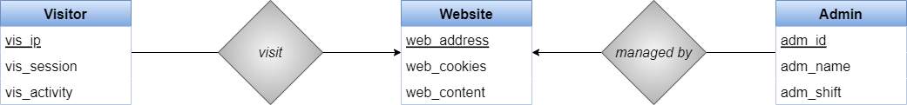

**FIGURE NO. 2 - ACTIVITY DIAGRAM**

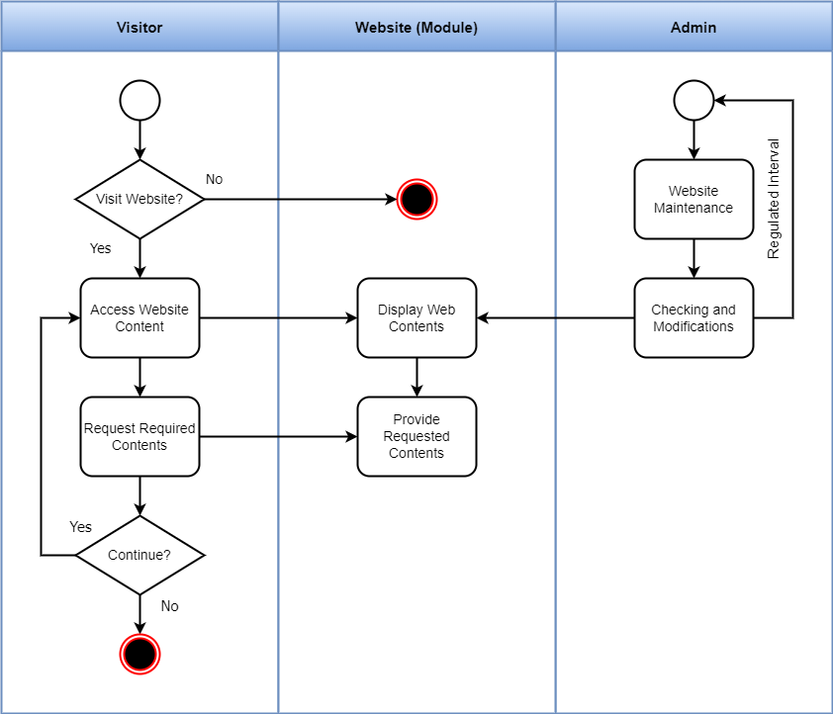

**FIGURE NO. 3. 1 - SEQUENCE DIAGRAM 1**

**(Visitor & Website Sequence)**

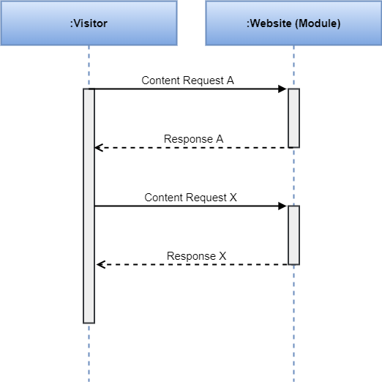

**FIGURE NO. 3.2 - SEQUENCE DIAGRAM 2**

**(Admin & Website Sequence)**

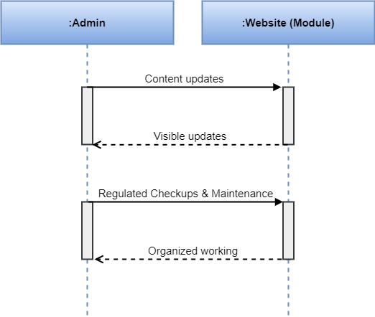

**FIGURE NO. 4 - USE CASE DIAGRAM**

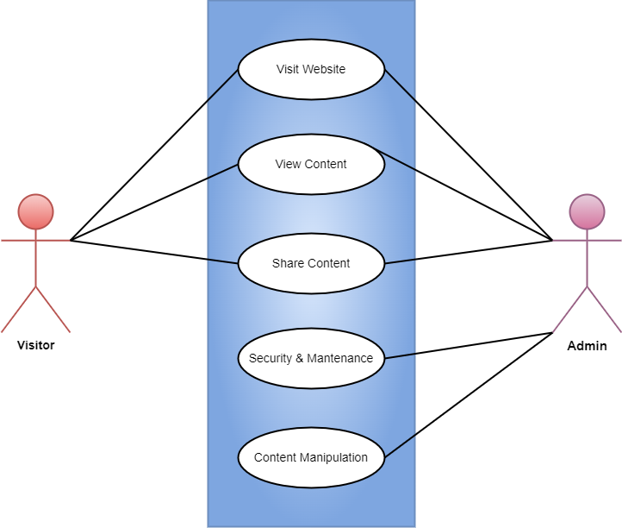

**FIGURE NO. 5 - DEPLOYMENT DIAGRAM**

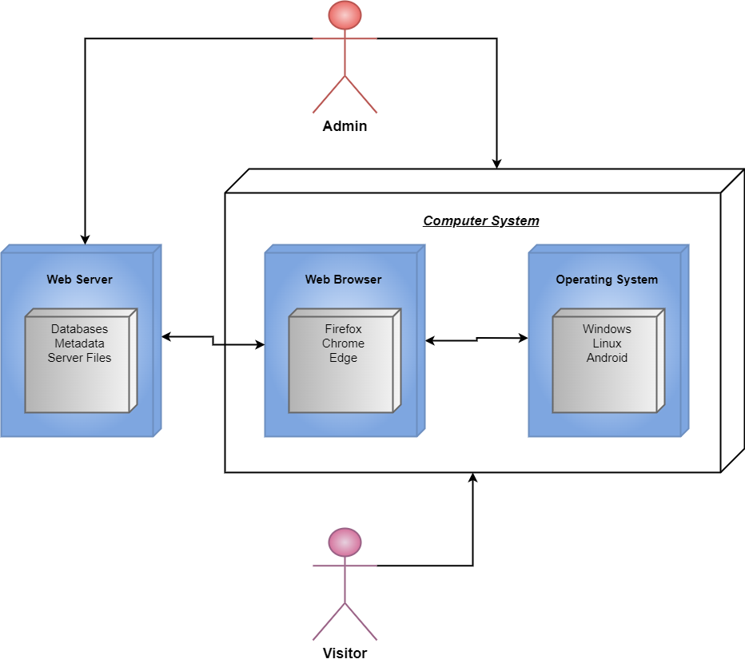

**FIGURE NO. 6 - COMPONENT DIAGRAM**

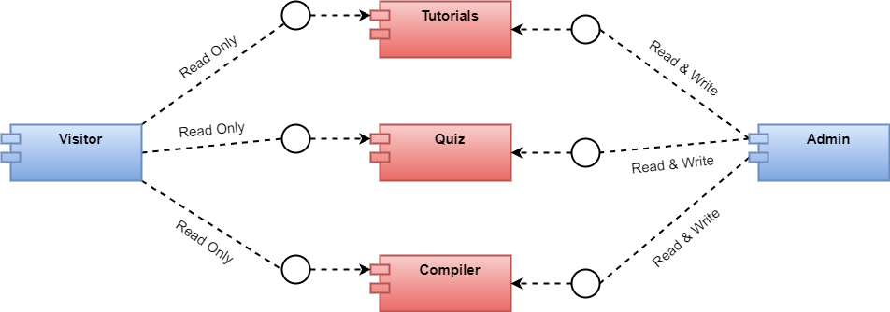

**METHODOLOGY**

A traditional approach involves a series of consecutive stages in the project management process. It is a step-by-step sequence to design, develop and deliver a product or service. It entails achieving the succession in the implementation process and provides the benefits of milestone-based planning and team building. In IT and software development, this methodology type is called “*Waterfall*” – one portion of work follows after another in linear sequence.

The following stages are included the traditional project management methodology:

* *Initiation (requirements specification)*
* *Planning and Design*
* *Execution (construction and coding)*
* *Control and Integration*
* *Validation (testing and debugging)*
* *Closure (installation and maintenance)*

**RESULTS**

1. An educative, simplified and an efficient Tutorial Website is developed. ‘BroCodes’ is user-friendly, modelled with a simplistic approach and is able to work on low-end systems as well.
2. With a simple andsnappy User Interface design, educative topics of C++ Programming Language are properly aligned and well-organized in an ascending series in terms of study.
3. ‘BroCodes’ website can help students or learners to research and study C++ programming skills and apply the obtained knowledge onto further skill strengthening and development.
4. The website can be consistently improved, managed and maintained in terms of both UI and functionality.

* ***OUTPUT***–

The User Interface design module for the project website i.e. Tutorials and Quiz Display & Evaluation output is resulted as given in the snapshots of system provided below:

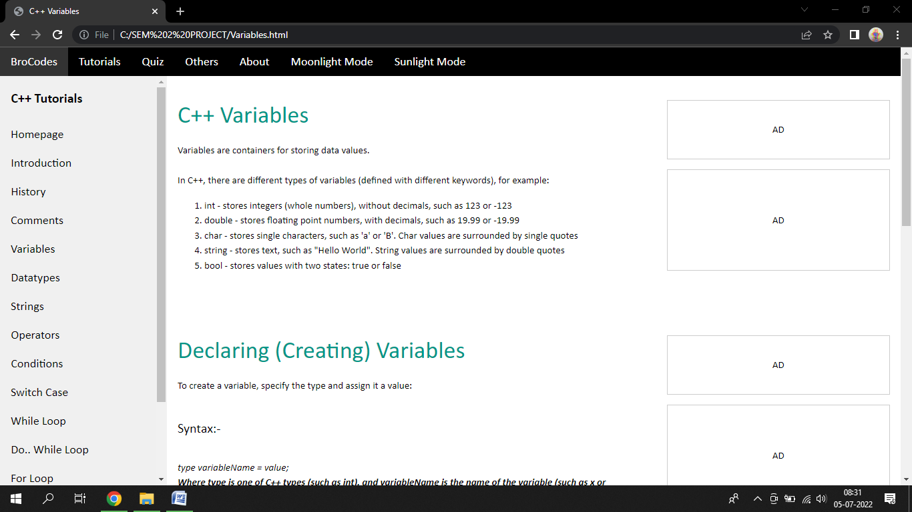

BROCODES UI - SUNLIGHT MODE (Light Theme)

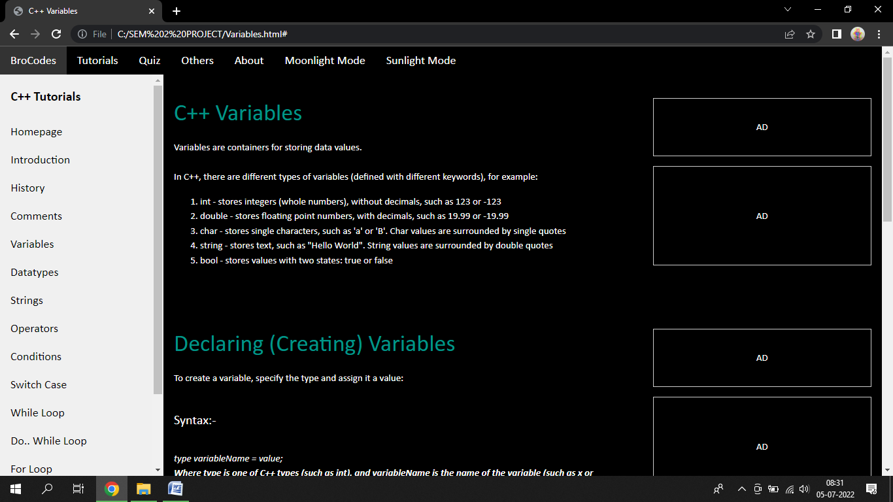

BROCODES UI - MOONLIGHT MODE (Dark Theme)

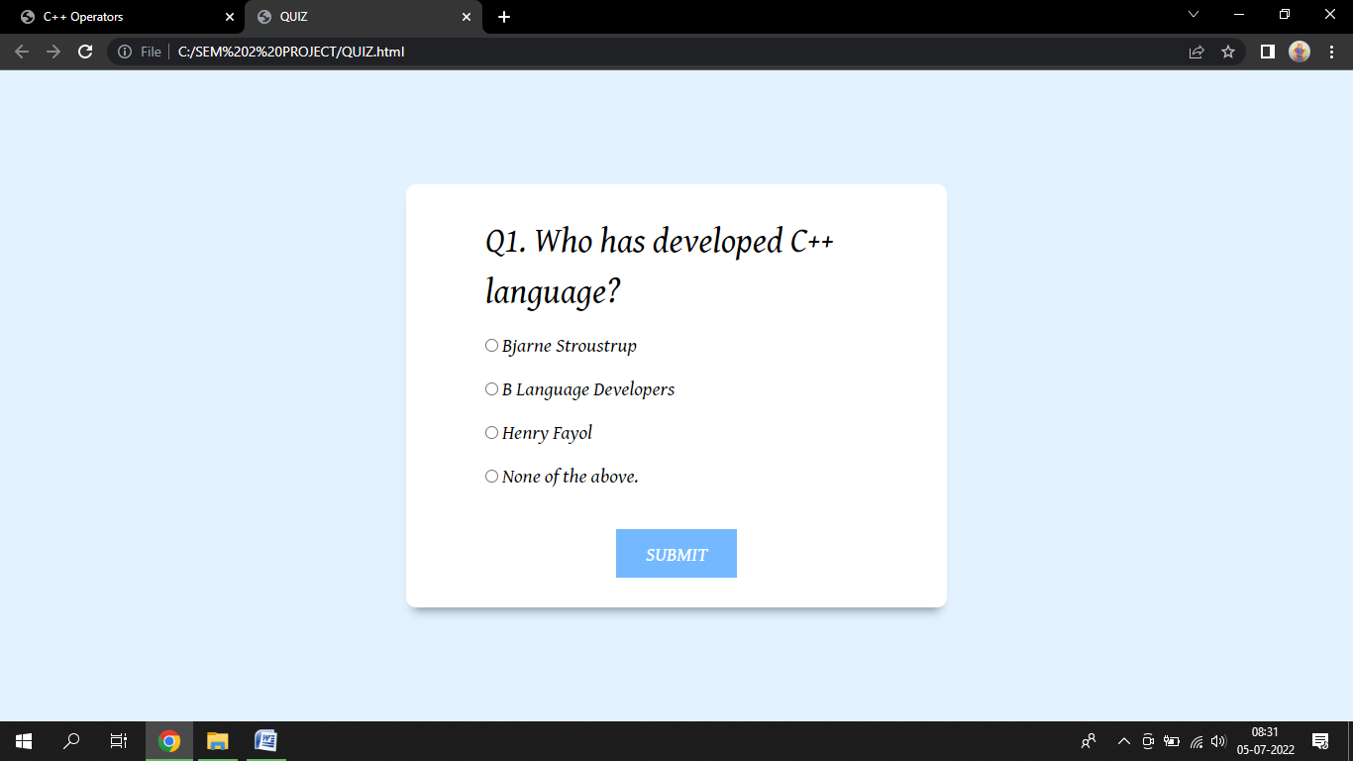

BROCODES UI – QUIZ DISPLAY

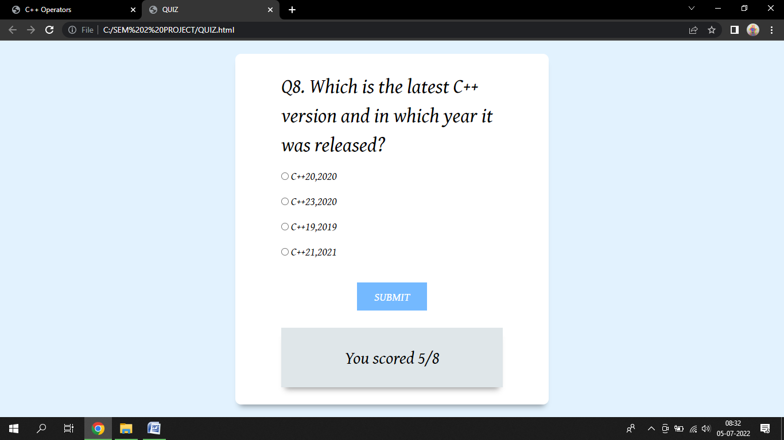

BROCODES UI – QUIZ EVALUATION

**TESTING**

The ultimate goal of functional testing is to ensure that software works according to specifications and in line with user expectations. While the objective sounds simple, the task involves many functional testing types, some of which might be preferred or prioritized over others depending on the nature of the application and organization.

For example, functional testing types like component, integration and system testing validate the ability to work in isolation or with other components, so the testing strategy might depend on how interoperable the app must be. Similarly, if an organization performs system testing, it might not perform acceptance testing, as that work might be considered redundant.

Another example: alpha, beta and production testing all describe builds that are in a production environment. Your choice between these functional testing types — or how the scale of people involved in each stage — might depend on the stability of the app, the scope of the changes, or timelines set by the business.

Types of testing performed on the project include:

* **UNIT TESTING**

Before you can test an entire software program, make sure the individual parts work properly on their own. Unit testing validates the function of a unit, ensuring that the inputs (one to a few) result in the lone desired output. This testing type provides the foundation for more complex integrated software. When done right, unit testing drives higher quality application code and speeds up the development process. Developers often execute unit tests through test automation.

* **COMPONENT TESTING**

Also called module testing, component testing checks individual parts of an application. Similar to unit testing, component testing assesses a part of the software in isolation from the broader system.

* **REGRESSION TESTING**

Just because functional tests pass once doesn’t mean they’ll always pass. When developers commit new code or change a feature, you run regression tests to make sure the software still functions as expected. Regression testing helps maintain a stable product while changes are made to it. Regression tests are often automated.

* **UI TESTING**

With UI testing, professionals interact with the graphical interface of a software program. This includes testing of UI controls like buttons, menus and text input to ensure that the experience flow and features chosen are optimal for the user experience.

* **SYSTEM TESTING**

With system testing, professionals test the software in its entirety, as a complete product. With this type of functional testing, testers validate the complete and integrated software package to make sure it meets requirements. Where necessary, testers can provide feedback on the functionality and performance of the app or website without prior knowledge of how it was programmed. This helps teams develop test cases to be used moving forward. System testing is also referred to as end-to-end testing.

***TEST CASES***

|  |  |  |
| --- | --- | --- |
| *Test* | *Description* | *Status* |
| ***1. Functional Testing*** | *To check whether the web pages are functioning as intended.* | *Passed* |
|  | *To check whether the given menus, options, commands are performing their specified actions.* | *Passed* |
|  | *To check whether the navigation between pages, topics is working* | *Passed* |
|  |  |  |
| ***2. UI Testing*** | *To check whether the UI elements are clearly visible and display their functionality clearly.* | *Passed* |
|  |  |  |
| ***3. Compatibility Testing*** | *To check whether the website application is running on latest operating systems e.g. Windows 10/11, Android 11/12, etc* | *Passed* |
|  | *To check whether the website application is running on all latest web browsers e.g. Google Chrome, Mozilla Firefox, Microsoft Edge, etc.* | *Passed* |

**CONCLUSION**

After all the analysis, study, designing, coding, testing and implementation, a final functioning product was produced. That product is a website with the tutorials and tests for the basics of C++ programming language concepts.

The name of the website created is ‘BroCodes’. It is developed using web design and development programming languages like HTML, CSS, and JavaScript.

This project currently serves it purpose of providing knowledge about the basics of C++ programming to its visitors or learners. It currently includes a Tutorial Section (with Theory and Programs) and a Quiz Section with MCQs (Multiple Choice Questions) related to the studied topics.

The website proves to be efficient in learning C++ program codes and theory. Learners, students or visitors are able the obtain the required information regarding given topics. Students studying under technical/software field are able to use the content to understand, revise and apply.

**FUTURE ENHANCEMENTS**

* **ACCOUNTS & LOGIN SYSTEM**

Login/User Authentication System can be implemented for all users to create a free account for the website and their personal information, history, bookmarks, plans will be saved in their own personal account which they can login using their username and password.

* **SUBSCRIPTION PLANS – BASIC / PRO**

Users will be offered various web learning plans to choose from e.g. Basic – with some limited features with a cheaper price and Pro – with some extended and enhanced features with a higher cost.

* **ENHANCED TESTS**

More types of learners’ tests can be implemented. Currently, the website contains MCQ tests for topics, in future, Timed tests, Blind tests, etc. can be included.

* **MARKETING / ON-SITE ADVERTISING**

On-site advertising can be improved and users must be able to choose personalized ads or general ads system.

* **FEEDBACK PORTAL**

A user feedback portal can be added to the site, where users can apply for suggestions, reviews for the websites since all types of users should be able to access, use and study from the site efficiently.

**BIBLIOGRAPHY**

* *CSS - Definitive Guide. By Eric Meyer, Oreilly Publication*
* *Web Technologies - 2nd Edition, Tata McHill by AchutGodbole*

**ACKNOWLEDGEMENT**

We would like to express our special thanks of gratitude to our Project Guide **Prof. Mariyam Maniyar**, Dept. Head **Prof. Dr. V. C. Bagal** and Principal **Dr. K. N. Nandurkar** who gave us the golden opportunity to work on this project on the topic **‘BroCodes’ : C++ Tutorials Website Design & Development.** It has helped us in doing a lot of research and we came to light about a lot of interesting concepts related to this topic.

Finally, we would also like to thank our parents and friends who helped us a lot in finalizing this project within the limited time frame.

- ‘BroCodes’ Project Team

*Dixit Vedant Haresh*

*Hingrajiya Shyam Niteshbhai*

*Shinde Aniket Rajendra*